Sequence Diagrams

- PLSP Questionnaire Project

Document Title | PLSP Sequence Diagram Documentation
Version | 1.1 (Reviewed)
Date | 21 May 2026
Related Documents | PLSP SRS v1.1 | Data Dictionary v1.1 | ER Diagram v1.1 | Menu and Permission Matrix | Functional Requirement

1. Introduction
This document describes the key system interaction flows for the PLSP system using UML sequence diagram notation. Each diagram is presented as a numbered step table showing the actor, component, and message for each interaction step.

1.1 System Components

Component / Actor | Role in Diagrams
Guest User | Anonymous participant—accesses questionnaire via QR/URL, submits answers, and views result.
Admin | Authenticated administrator — manages questionnaires, users, exports, and views logs.
Executive | Authenticated viewer—accesses dashboards and exports analytical reports.
Frontend (Vue.js,  Nuxt.js) | Client-side browser application that renders UI and sends API requests.
Backend API (NestJS) | Server-side API handling business logic, authentication, scoring, and data access.
Database (MySQL) | Persistent storage for all entities.
Cache (Redis) | Temporary storage for frequently accessed data and generated exports.

1.2 Sequence Diagram Index
ID | Flow Name | Description
SD-01 | Guest Questionnaire Submission | Anonymous guest accesses, answers, and submits a questionnaire. The system calculates and displays results.
SD-02 | Admin — Questionnaire Creation | Admin logs in, creates a questionnaire, adds questions, and opens it for submissions.
SD-03 | Admin — Export Report | An admin or executive requests a report export in a selected format.
SD-04 | Executive — View Dashboard | Executive logs in and accesses the analytical dashboard.

SD-01 — Guest User: Anonymous Questionnaire Submission
This flow covers a guest user accessing an open questionnaire via QR code or URL, submitting answers anonymously, and receiving their learning style result.
Preconditions
- Questionnaire exists in the system with status = Open.
- Guest user has a valid QR code or direct URL.
- No authentication is required.
Postconditions
- Submissions and answers are saved to the database.
- Result records are calculated and saved per category.
- Guest user sees their learning style result summary.
Interaction Steps
Step | From | To | Message / Action
1 | Guest User | Frontend | Scans QR code or opens direct URL for the questionnaire.
2 | Frontend | Backend API | GET /questionnaire/{id}
3 | Backend API | Database | Query Questionnaire by ID. Validate status = Open.
4 | Database | Backend API | Return questionnaire data + questions list.
5 | Backend API | Frontend | Return { title, questions[], categories[] }.
6 | Frontend | Guest User | Render questionnaire page and display all questions.
7 | Guest User | Frontend | Selects answers for each question and clicks Submit.
8 | Frontend | Backend API | POST /submission { questionnaireID, answers[] }
9 | Backend API | Backend API | Generate anonymousSessionID. Validate all answers present.
10 | Backend API | Database | INSERT Submission record { questionnaireID, anonymousSessionID, submittedAt }.
11 | Backend API | Database | INSERT Answer records for each { SubmissionID, QuestionID, selectedValue }.
12 | Backend API | Backend API | Calculate rawTotalScore and percentage per Category from submitted answers.
13 | Backend API | Database | INSERT Result records for each Category { submissionID, categoryID, rawTotalScore, percentage, calculatedAt }.
14 | Backend API | Frontend | Return result summary { categories[], scores[], percentages[] }.
15 | Frontend | Guest User | Display learning style result summary with scores per category.

SD-01 — Guest User: Anonymous Questionnaire Submission

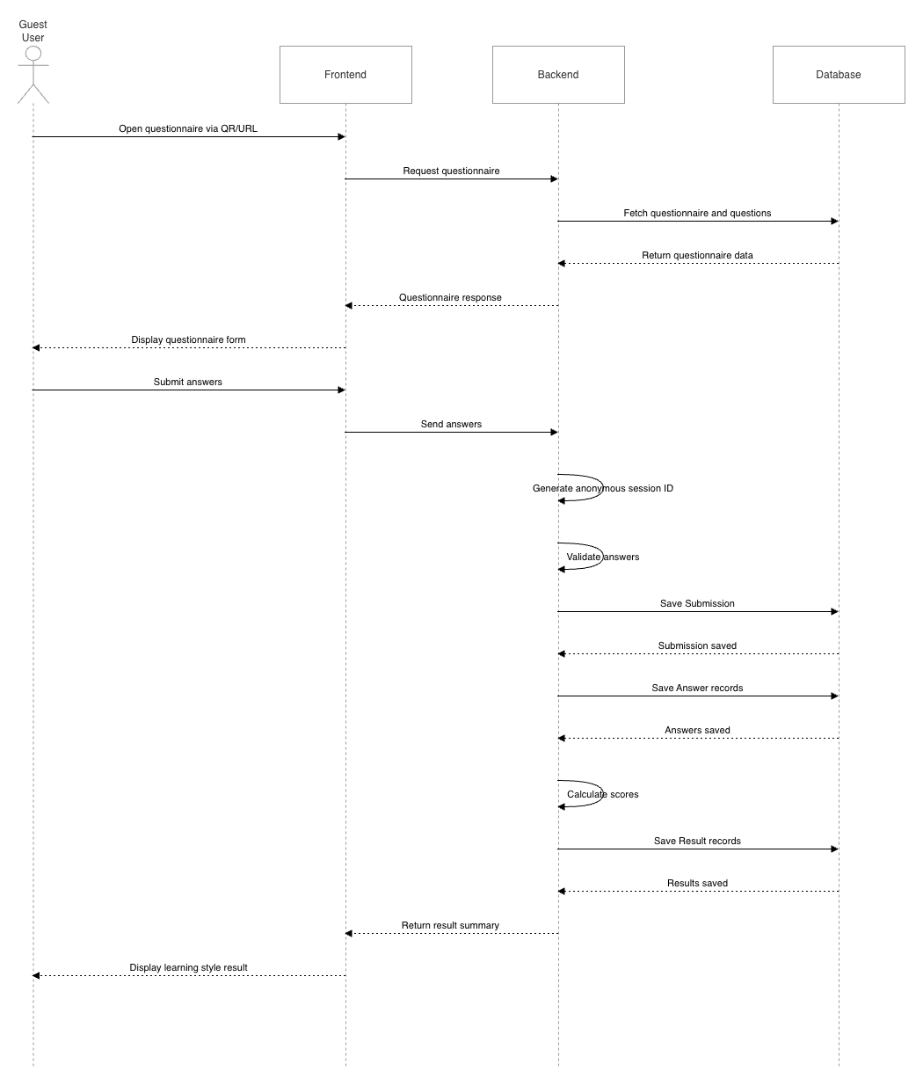

SD-02 — Admin: Questionnaire Creation
This flow covers an admin logging in, creating a new questionnaire with questions, assigning categories, and opening it for guest submissions.
Preconditions
- Admin has a valid registered account.
- Categories already exist in the system.
Postconditions
- Questionnaire is created with status = Draft, then updated to Open.
- Questions are linked to the questionnaire and categories.
- AuditLog entries are written for CREATE and OPEN actions.
- QR code and shareable URL are generated.
Interaction Steps
Step | From | To | Message / Action
1 | Admin | Frontend | Navigates to login page. Enters email and password.
2 | Frontend | Backend API | POST /auth/login { email, password }
3 | Backend API | Database | Query User by email. Validate bcrypt password hash.
4 | Backend API | Frontend | Return JWT access token (role: Admin).
5 | Frontend | Admin | Redirect to Admin Dashboard.
6 | Admin | Frontend | Fills in questionnaire title, adds questions, assigns categories. Clicks Save.
7 | Frontend | Backend API | POST /questionnaire { title, questions[], categoryIDs[] } [JWT Header]
8 | Backend API | Backend API | Validate JWT. Confirm role = Admin.
9 | Backend API | Database | INSERT Questionnaire { title, status: Draft, createdBy, createdAt }.
10 | Backend API | Database | INSERT Question records for each { questionnaireID, categoryID, questionText }.
11 | Backend API | Database | INSERT AuditLog { userID, action: CREATE_QUESTIONNAIRE, details, timestamp }.
12 | Backend API | Frontend | Return { questionnaireID, status: Draft }.
13 | Admin | Frontend | Clicks "Open Questionnaire" to make it available for submissions.
14 | Frontend | Backend API | PATCH /questionnaire/{id}/status { status: Open } [JWT Header]
15 | Backend API | Database | UPDATE Questionnaire status = Open. INSERT AuditLog { action: OPEN_QUESTIONNAIRE }.
16 | Backend API | Frontend | Return { questionnaireID, status: Open, qrCodeURL, shareableURL }.
17 | Frontend | Admin | Display QR code and shareable URL for distribution.

SD-02 — Admin: Questionnaire Creation
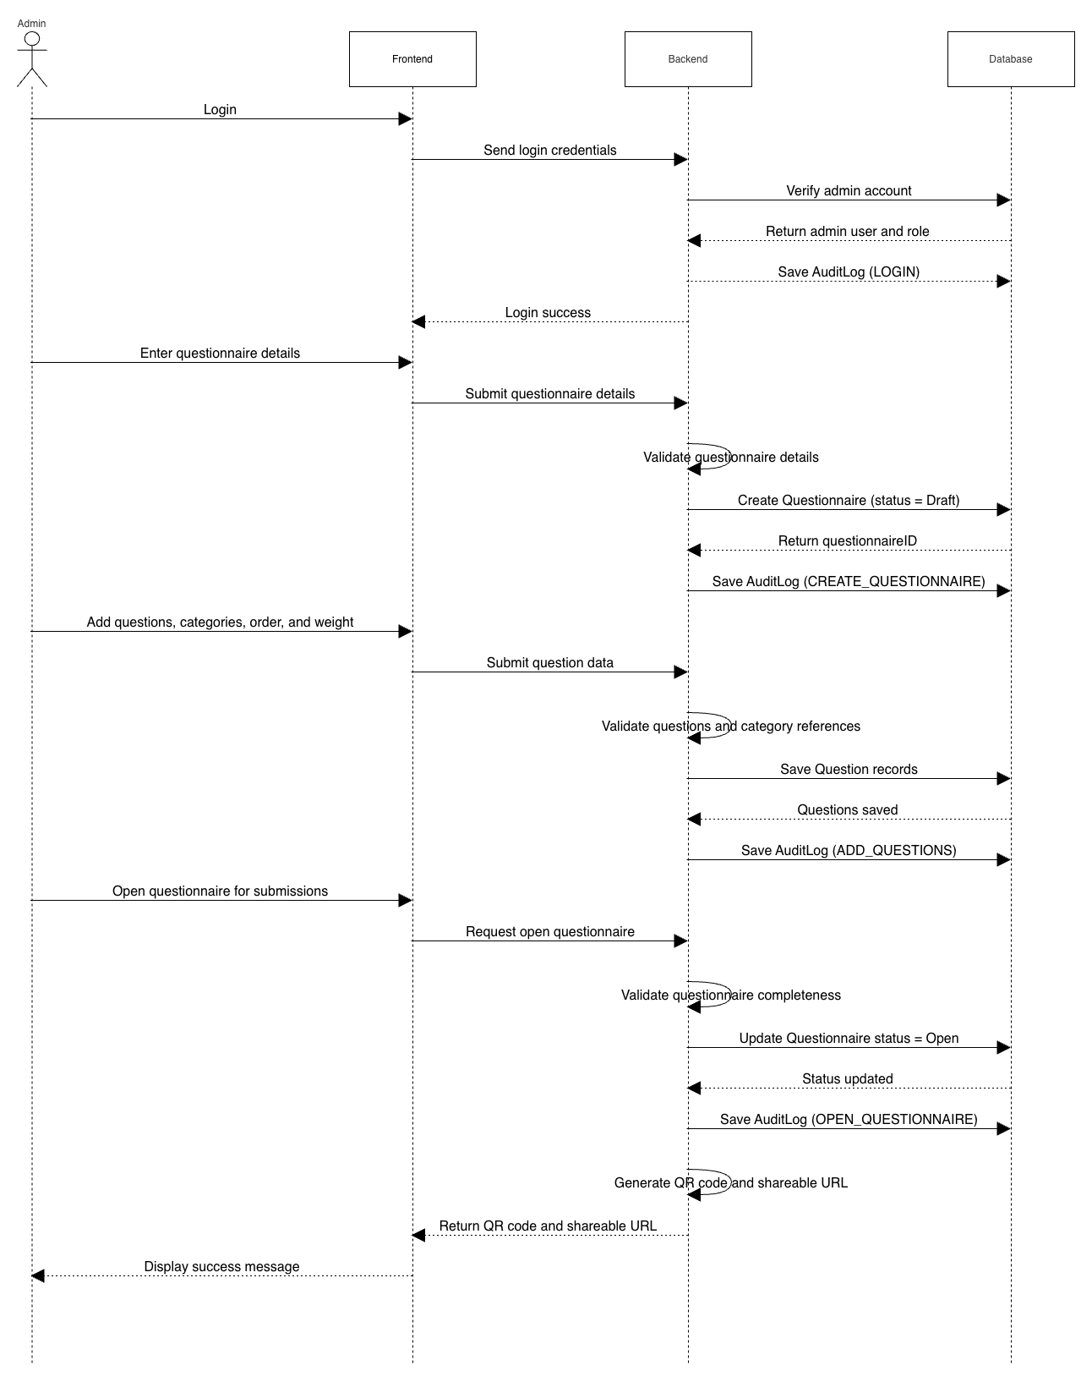

SD-03 — Admin: Edit Questionnaire
Purpose
This flow covers an Admin editing an existing questionnaire, updating its details or questions, and saving changes.
Preconditions
- Admin has a valid account.
- Admin is logged in.
- Questionnaire already exists.
- Questionnaire status is Draft or Closed.
- Questionnaire should not be edited while it is Open, unless your system allows it.
Postconditions
- Questionnaire details are updated.
- Question records are updated.
- AuditLog records are saved.

Interaction Steps
Step | From | To | Message / Action
1 | Admin | Frontend | Opens questionnaire management page.
2 | Frontend | Backend API | GET /questionnaires [JWT Header]
3 | Backend API | Backend API | Validate JWT. Confirm role = Admin.
4 | Backend API | Database | SELECT questionnaires.
5 | Backend API | Frontend | Return questionnaire list.
6 | Frontend | Admin | Display questionnaire list.
7 | Admin | Frontend | Selects questionnaire to edit.
8 | Frontend | Backend API | GET /questionnaire/{id} [JWT Header]
9 | Backend API | Database | SELECT Questionnaire and Question records by questionnaireID.
10 | Backend API | Frontend | Return questionnaire details and questions.
11 | Frontend | Admin | Display questionnaire edit form.
12 | Admin | Frontend | Updates title, questions, category, order number, or weight. Clicks Update.
13 | Frontend | Backend API | PUT /questionnaire/{id} { title, questions[], categoryIDs[], orderNo[], weight[] } [JWT Header]
14 | Backend API | Backend API | Validate JWT. Confirm role = Admin.
15 | Backend API | Backend API | Validate questionnaire status and updated data.
16 | Backend API | Database | UPDATE Questionnaire { title, updatedAt }.
17 | Backend API | Database | UPDATE Question records { questionText, categoryID, orderNo, weight, updatedAt }.
18 | Backend API | Database | INSERT AuditLog { userID, action: UPDATE_QUESTIONNAIRE, details, timestamp }.
19 | Backend API | Frontend | Return questionnaire update success response.
20 | Frontend | Admin | Display success message.

SD-03 — Admin: Edit Questionnaire
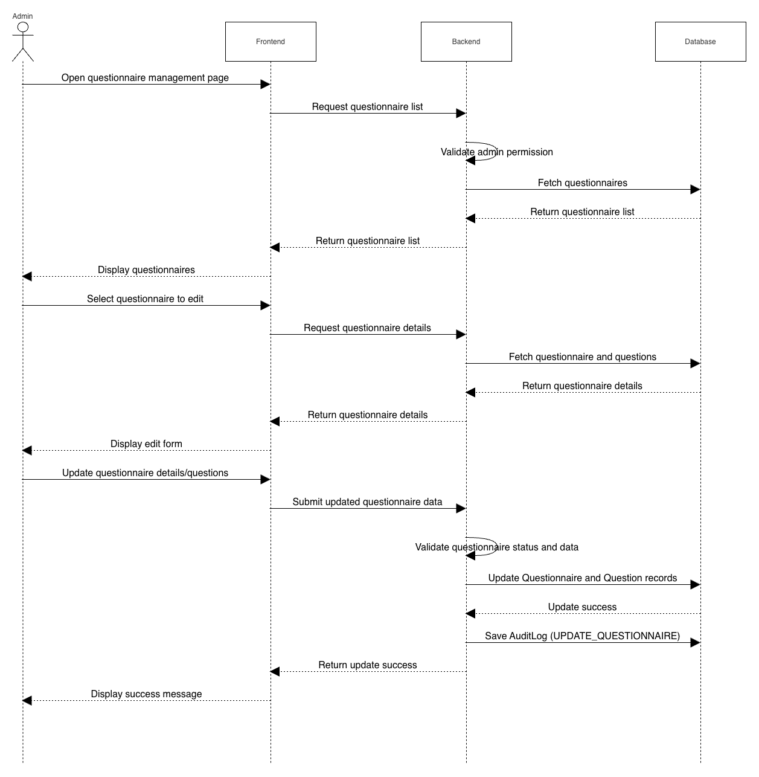

SD-04 — Admin / Executive: Export Report
This flow covers an authenticated Admin or Executive requesting an analytical report export in a chosen format (PDF, CSV, Excel, or PNG).
Preconditions
- User is authenticated with role Admin or Executive.
- At least one questionnaire with completed submissions exists.
Postconditions
- Report file is generated and downloaded by the user.
- AuditLog entry is written for the EXPORT_REPORT action.
Interaction Steps
Step | From | To | Message / Action
1 | Admin / Executive | Frontend | Opens analytics dashboard.
2 | Frontend | Backend API | GET /analytics/dashboard [JWT Header]
3 | Backend API | Backend API | Validate JWT. Confirm role = Admin or Executive.
4 | Backend API | Database | SELECT aggregated Result and Submission data.
5 | Backend API | Frontend | Return analytics dashboard data.
6 | Frontend | Admin / Executive | Display dashboard charts and export options.
7 | Admin / Executive | Frontend | Selects export format (PDF, CSV, Excel, or PNG). Clicks Export.
8 | Frontend | Backend API | POST /reports/export { format } [JWT Header]
9 | Backend API | Backend API | Validate export request and selected format.
10 | Backend API | Database | SELECT report and analytical data.
11 | Backend API | Backend API | Generate report file based on selected format.
12 | Backend API | Database | INSERT AuditLog { userID, action: EXPORT_REPORT, details, timestamp }.
13 | Backend API | Frontend | Return generated report file.
14 | Frontend | Admin / Executive | Download exported report file.

SD-04 — Admin / Executive: Export Report
